Busy Life Easy Solution
Software Solution| Web & Mobile Application | E-commerce

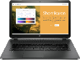
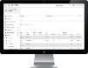
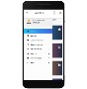
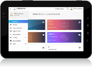
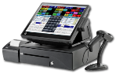

7th Floor, House No-52/1, Hasan Holdings, New Eskaton Road, Banglamotor, Dhaka, Bangladesh – 1000. Phone: 01643-235522, 01643-235533
E-mail: shomikaron@gmail.com, Website: www.shomikaron.com

Company Overview

Company Name | Shomikaron
Business Function | Website design & development, software development, Training, Digital Marketing,  Game Development, Graphics design, Electronics device
Corporate Office Address | Hasan Holdings, House - 52/1, 7th Floor, New Eskaton Road, Banglamotor, Dhaka– 1000, Bangladesh.
Total Employees | 30
Website Address | www.shomikaron.com
Company Email | shomikaron@gmail.com
Company Hotline | +880 1643-235 533
Areas of Expertise | Domain Registration, Hosting Server, Web Design & Development, E-commerce Development, Software Development, Mobile Applications, Bulk SMS Server, Website maintenance, IT consultancy, IT support services, Mobile Games, SEO, SEM, SMM, Graphics Design
Market Coverage | Bangladesh, USA, UK, Canada, Australia, Saudi Arabia, Dubai, India

Company Summary
Shomikaron is a Software and Hardware Solution, System integration and consulting company, which is growing its business in Bangladesh IT, Telecom and Digital Ecosystem. We are a unique combination of deep technical expertise and creative thinking with a wealth of experience consulting, designing and deploying of millions dollar projects worldwide. We acquire, manage and build industry specific software businesses that provide specialized, mission-critical software and hardware solution that address the particular needs of our customers. Our businesses continuously develop innovative solutions that enable our customers to achieve their objectives.
Shomikaron was registered as a private company under companies act 1994 on 4th March, 2018. Within the short the Shomikaron already develop and delivered School management solution to school, AC land office and multiple corporate companies.
Our company has the reputation for being the best website design and development, software development, hardware Solution Company in Bangladesh, making our customers happy with our efficient and innovative solutions. We give IT solutions to big companies that want to get their business to a whole new level. Whether to make a new website to start the online business or restructuring the old one or make a new software to automate the production or service process that the company is giving, we are prepared to provide solutions to all these problems.
We are a Bangladesh based IT Solutions Company, which is dedicated to giving total IT solution to any company that is just starting out or is already reputed enough but require IT services that can guarantee efficiency and quality. We have a team of reputed IT professionals who have experience working in the IT industry for a long time. They are versatile and have worked in various environments that challenged and honed their professional expertise. They have worked for foreign companies that accept only top level work. This experience has made our company unique and earned us the title of the best IT Company in Bangladesh. When an organization looks for a good website design and development company in Bangladesh, they will surely look for quality in their work. So quality is one of our top priorities. No other software company in Bangladesh will give you the level of satisfaction that we will give which you surely deserve. We know how much time is precious to you. That is why we try to meet your goals in the given time. Our professionals are experts in most development platforms that are widely used.
Our dedication to delivering, determination for maintaining quality, the simplicity of the developed systems and time management has made us the best in the industry of website design and Development Company in Bangladesh.
Website development is our main service in Software Solution. We are proficient of creating magnificent & flawless website from scratch to a full furnished product. Our customers are not only native but also from the whole world. Our variety of works shows that, Any Kind of website? Yes we can make it for you. Our diversified client list proves our worthiness. So if you are thinking a world class website design & classy website development, Software Solution the Best Web Design Company in Bangladesh is your one stop solution.
Every impression counts when it comes to capturing customers online. Now more than ever, your online image is essential to the success of your business. A fancy design is not enough for your site now a day’s user are demanding websites that are user friendly, informative, attractive, and accessible as well as responsive to all devices.

Device Friendly Website Development and Software Development
Update Your Content Any Time You Want
Sell Your Product by Your Website

Our Product & Solutions
- E-Commerce Websites
E-Commerce websites take brochure websites a step further by allowing you to shop directly from your computer. The main difference between a brochure site and an e-commerce site is that the latter features a checkout system to enable you to order directly from the online store. There are a number of plugins and pre-built options available, and your shopping cart choice depends greatly on your specific product and business.
For an e-commerce site, here are a few of the variables that will affect the total price of the site you intend to build:
- How many products/services and the type of product/service you want to sell?
- Shopping cart solution (custom versus third-party software)?
- SSL Certificate provider and security level?
- Choice of hosting provider and the configuration of the hosting service
- News and Magazine Website

News websites can be intriguing to examine from a design perspective. Regardless of what type of news they cover, they all face the challenge of displaying a huge amount of content on the home page, which creates plenty of layouts, usability and navigational challenges for the designer. The lessons that can be learned from examining how news websites address these challenges can be valuable for designers who work with other types of websites, including ones with blog theme designs.
- Business Website

As a business owner, you need to know where your consumers are. But what if consumers know your business and what you can offer, but they can’t reach you? That is one of the risks you take by not having a website for your business.
Shomikaron has the right solution for any kind of business. We know your time is valuable so we prepared all the content you'll need to take your business live and online. While building your website, you can choose from a wide variety of professionally designed templates. You don’t even have to worry about the texts – we prepared basic content for more than 100 business fields. All you need to do is register, choose the best template for your business and fill in the information your customers need to know about you.
- Government Website

Government website is the use of communications devices, computers and the Internet to provide public services to citizens.

Today's government and commercial organizations face significant challenges in these days of tight budgets, smaller pools of both human and capital resources to maintain effectiveness in meeting the needs of the constituents they serve. Add to this, the challenge of managing tens of thousands of documents through the normal course of municipal operations while increasing personnel productivity and lowering the cost of providing mission critical services.

In this day and age, government websites serve not only as a resource of information for citizens, but through interactive features, can also provide a range of services such as e-payments, license renewals and social media. So by now, there must be features that are absolutely essential for any government website

We have all seen the power of a dynamic web presence in creating the desire to visit again and again. Whether it’s an inviting front page, colorful graphics, ease of navigation or most importantly…timely and useful information: getting and retaining visitors is no longer a mystery. No matter what the industry or the size of the organization, the key to such vibrancy is the ability to easily and quickly add, edit and change the web’s content, for it is the content that drives the success of any web site. After all, it’s the content/information that your audience is seeking….timely, fresh, useful information.
- Travel Website
Shomikaron has been offering travel software solutions to the travel industry since its inception. We provide travel website development that empowers companies to deliver a fully loaded online travel booking website that goes well beyond customer expectations.
We create custom software, tools and websites for the Travel Industry, delivering user friendly, business focused and commercially viable solutions.
We are committed to pushing the boundaries of what's possible in online travel, by helping travel companies unlock potential, realize ideas and develop revenue streams.
By giving our clients the tools they need to engage with customers, we allow them to react to new opportunities as they arise and always keep them one step ahead of the competition.

No other travel technology solutions provider offers such wide range of bookable solutions for Online Travel Agencies with most affordable package in the industry.
- Restaurant website

We are leaders in restaurant website design. Your website should be designed by experts who specialize in your industry. Gourmet marketing has deep experience in restaurant website design. Our clients come from around the world, from fast-casual to fine dining. We use the latest technology and marketing tools to put your restaurant’s website ahead of the competition.

We listen to our clients and learn from them. With over 5 years of experience working with restaurant owners nationwide it allows us to understand what they want and what they need to compete in today's marketplace.

Restaurant website designs are "Responsive" meaning that when your customer visits your website from their desktop, tablet or Smartphone the website will auto-format to fit the screen perfectly. Your new website needs to be user-friendly and mobile-friendly. If your existing website is not mobile-friendly Google will lower your ranking on the search results. Your competitor's websites that are mobile-friendly will rank higher on Google than your website. That can negatively affect the amount of potential customers going to your website resulting in less revenue. Hire Restaurant By Shomikaron and we will take the necessary steps to get your Restaurant website higher up on the Google search results and the other major search engines like Yahoo and Bing.

We offer Restaurant Website design packages that include everything you need to get your website up and running. The following services are included in each package; design of the website, hosting, email service, lead generation forms, search engine submissions, updates, and support.
- School or College Website
Many education institutions lack proper analytics and the ability to track results from their marketing efforts. We help education organizations improve their data and analytics capabilities and make better decisions on how to engage their user base. We use marketing automation to track user activity, lead activity and build better segmentation models.
Shomikaron provides websites for schools, school website design and development.
This special school website solution provides a large range of sections and functionality. This allows the school to enjoy all the benefits of a professional website right from the start, plus the option to add sections later as school needs change.

- Point Of Sales Software
A point-of-sale (POS) terminal is a computerized replacement for a cash register. Much more complex than the cash registers of even just a few years ago, the POS system can include the ability to record and track customer orders, process credit and debit cards, connect to other systems in a network, and manage inventory. Generally, a POS terminal has as its core a personal computer, which is provided with application-specific programs and I/O devices for the particular environment in which it will serve. A POS system for a restaurant, for example, is likely to have all menu items stored in a database that can be queried for information in a number of ways. POS terminals are used in most industries that have a point of sale such as a service desk, including restaurants, lodging, entertainment, and museums.
Increasingly, POS terminals are also Web-enabled, which makes remote training and operation possible, as well as inventory tracking across geographically-dispersed locations. Module: Products, Customers, Sales Module, Invoice view (Standard or Tax Invoice), Ability to add, manual product to order list, Ability to sell gift cards , Instant discount (add percentage or fixed discount to order and/or any product), Warehouse code/name/address on invoice, Return sales and issue refunds, Record payments to sale (full/partial with any no of payments), Add payment terms (No of pending payment days before the sale marked as due), Sale status (pending/completed), Payment status (pending/due/partially paid/fully paid)), Reports, Improved old reports, Added product expiry alerts, Added payments report, Added profit and loss report, Added customer report, Added supplier report, Added staff report.
- School Management Software
The school administration is most important part of school. Manage school day to day activities is very difficult for the school administration department. Shomikaron helps to educational institute to reduce the time and maintain school data accuracy. The school administration module contains master values as configuration to retrieve data in other modules. User can create pre-structure in advance which is helping to complete the various tasks in some clicks.
- Enterprise Resource Planning (ERP)
Enterprise resource planning (ERP) is business process management software that allows an organization to use a system of integrated applications to manage the business and automate many back office functions related to technology, services and human resources. ERP software integrates all facets of an operation, including product planning, development, manufacturing, sales and marketing.
ERP software is considered an enterprise application as it is designed to be used by larger businesses and often requires dedicated teams to customize and analyze the data and to handle upgrades and deployment. In contrast, Small business ERP applications are lightweight business management software solutions, customized for the business industry you work in.
ERP Software Modules: ERP software typically consists of multiple enterprise software modules that are individually purchased, based on what best meets the specific needs and technical capabilities of the organization. Each ERP module is focused on one area of business processes, such as product development or marketing. A business can use ERP software to manage back-office activities and tasks including the following:
Distribution process management, supply chain management, services knowledge base, configure, prices, improve accuracy of financial data, facilitate better project planning, automate employee life-cycle, standardize critical business procedures, reduce redundant tasks, assess business needs, accounting and financial applications, lower purchasing costs, manage human resources and payroll.
Some of the most common ERP modules include those for product planning, material purchasing, inventory control, distribution, accounting, marketing, finance and HR.
As the ERP methodology has become more popular, software applications have emerged to help business managers implement ERP in to other business activities and may incorporate modules for CRM and business intelligence, presenting it as a single unified package.
The basic goal of using an enterprise resource planning system is to provide one central repository for all information that is shared by all the various ERP facets to improve the flow of data across the organization.
Our Service
- Customized Website Design & Website Development, Software Development
- Responsive Website Development.
- Website Hosting
- Peer to peer working experience
- Website Management
- Software integration
- Website Promotion
- Hardware Solution
If you are looking for the best website and software Development Company in Bangladesh you found the right one.

Legal Info

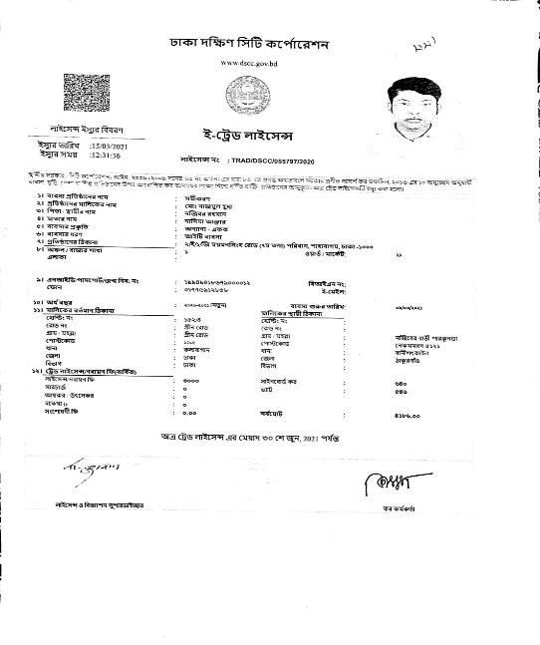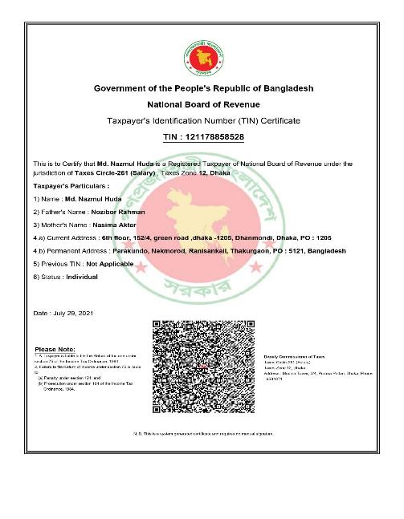

Bank Information
Shomikaron maintains his account in ever branch that has. Shomikaron mainly maintains a mother account that controlled all transaction of this organization.
Bank Name: Bank Asia Ltd
Account Name: Shomikaron
Account Type: Current Account
Account Number: 08533000579
Address: Bank Asia Ltd, BSMMU Branch, Mymenshing Road, Paribag, Shahabag, Dhaka

Client List

Government Office:
- ACland dhanmondi Circle, Dhaka
- ACland Motijheel Circle, Dhaka
- ACland Demra Circle, Dhaka
- ACland Ramna Circle, Dhaka
- ACland Tejgaon Circle, Dhaka
- ACland Mohammadpur Circle, Dhaka
- ACland Gulshan Circle, Dhaka
- ACland Cantonment Circle, Dhaka
- ACland Kotowali Circle, Dhaka
- ACland Narayanganj Circle, Narayanganj
- ACland Fatullah Circle, Narayanganj
- Dhaka DC Office
- Ministry of local Government and Rural Development (LGD)
- Dhaka Divisional Commissioner office
- Ministry of Public Administration (mopa)
- UNO Office Narail
- UNO Office Shalikha
- Jhenaidah DC Office
- Divisional Primary Education Office, Khulna
- Divisional Primary Education Office, Dhaka
- Rajdhani Unnayan kartripakkha (Rajuk)
- Dhaka Bar Association

